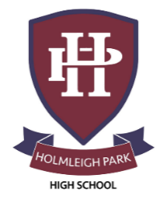
Super Curriculum – Year 12 & 13



Subject: Physical Education

Reading Task Location to Visit

Research Task Creative Task

Listening Task Writing Task


Watching Task Independent Project

‘The Sports Gene’, by David  Epstein | ‘Bounce’, by Matthew Syed | ‘The Talent Code’, by Daniel Coyle
Icarus (2017) a documentary examining doping in sports | BBC One Panorama – Catch me if you can  https://www.youtube.com/watch?v=04ck8LwApd4 | At least one biography of a top sportsman/woman
Write a glossary of anatomy and physiology used in your sport | Write a coaching plan for any  sport | Watch The Program (2015), a film about Lance Armstrong
Gold Rush, on iPlayer  https://www.youtube.com/watch?v=_o4mPZ7Oo5Y | Write two contrasting arguments for the following:  • Drug cheats should be banned for life from all sport  • All drugs should be allowed in sport | Create a timeline of the history of your chosen sport.
  Represent the school in any sport including House Sports.  Challenge yourself to represent the county. | Perform for a sports club and  challenge yourself to attend a  new one | Lead a session at a club, or in school, working with younger athletes

