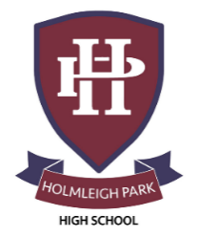
Super Curriculum – Year 12
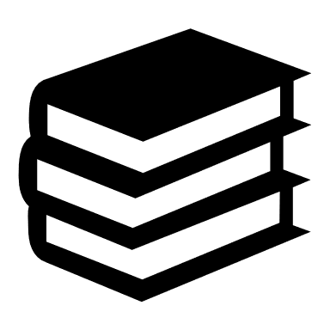


Subject: English Literature

Reading Task Location to Visit

Research Task Creative Task

Listening Task Writing Task
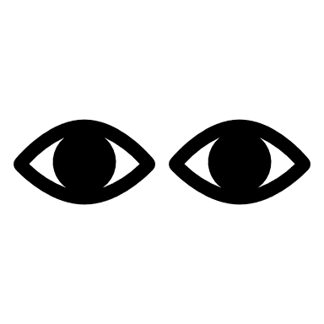

Watching Task Independent Project

Set up a student magazine for the sixth form | Set up a creative writing rag for the sixth form | Watch a variety of productions of the set plays, either amateur or professional
Attend a free talk at The British Library –  https://www.bl.uk/events | Start up a book group | Research a writer you particularly like and focus a small research project on them – great for university interviews!
Write an article for an E-Mag on one of the texts you have studied this year. | Write your own short story. | Keep a scrapbook of interesting articles, books you have read.
Cheltenham Literary Festival. 10th-19th October 2025  https://www.cheltenhamfestivals.com/literature/ | Read or better still watch some of Shakespeare’s tragedy plays – speak to your English teacher for guidance | Read reviews of current releases to stay ahead of what’s happening in the world of literature today!
A literary magazine, based in London.  https://literaryreview.co.uk/ | An English language literary magazine, based in Paris.  https://www.theparisreview.org/ | ‘The Girl with the Dragon Tattoo’, by Steig Larsson

