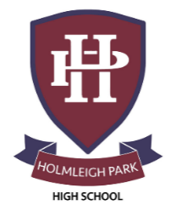
Super Curriculum – Year 12



Subject: Environmental Science
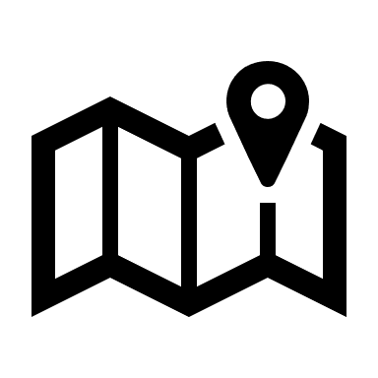
Reading Task Location to Visit

Research Task Creative Task
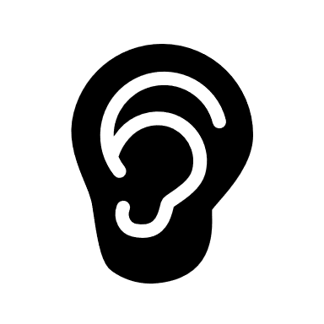
Listening Task Writing Task

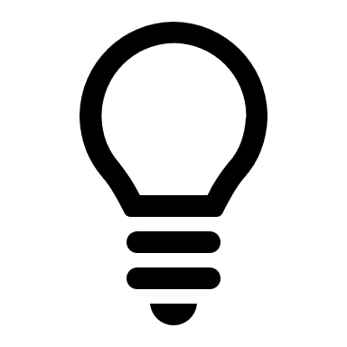
Watching Task Independent Project
Read journals on everything from bats https://www.nature.com/to geothermal heating! | Delve into the Cambridge Natural Sciences reading list  https://www.natsci.tripos.cam.ac.uk/prospective-students/reading | ‘This changes Everything, by Naomi Klein
Watch videos on all sorts of Environmental Science topics!  https://www.ibiology.org/playlists/environmental-sciences/ | Cambridge Science Festival – happening online this year!  https://www.festival.cam.ac.uk/ | Read articles on a range of topics on National Geographic https://www.nationalgeographic.com/
Listen to podcasts offered by the University of Oxford  http://podcasts.ox.ac.uk/series/school-geography-and-environment-podcasts | Stay up to date with current news and developments  https://www.bbc.co.uk/news/science_and_environment | Download and listen to  podcast ‘Costing the Earth’  https://www.bbc.co.uk/programmes/b006r4wn
Watch science lectures, from the Royal Society  https://www.youtube.com/user/RoyalSociety/featured | Explore all things science with Oxford Sparks  https://www.oxfordsparks.ox.ac.uk/ | Examine the data and maps at Our World in Data  https://ourworldindata.org/
Explore Natural Science through google https://artsandculture.google.com/story/0wWBHNbzoDYULw?hl=en | The Science Museum in London. Tickets are free, but you must pre-book! Everything from Space to Zoology. | The Cheltenham Science Festival. 2-7th June 2026.  https://www.cheltenhamfestivals.org/festivals/science-festival

