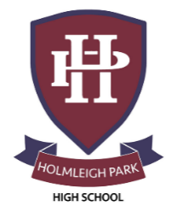
Super Curriculum – Year 12 & 13



Subject: French

Reading Task Location to Visit

Research Task Creative Task

Listening Task Writing Task


Watching Task Independent Project
Read another book by the author of your set book and write a review. | Go online and read Le Point or  Le Monde. Note down 20 new items of vocab.  https://www.lemonde.fr/  http://www.lepoint.fr | Watch another film by the  filmmaker you are studying and write a review. Watch first with English subtitles and then with French. Watch a French TV series on Netflix
Watch one (or more) films:  Elle s’appelait Sarah  La rafle  Intouchables  A la folie, pas du tout  Amélie | Watch the daily news online  https://www.newsinslowfrench.com/ | A great resource for new  daily content from RFI  (Radio France International)  for all who are  learningFrench  https://www.rfi.fr/en/
Find out about another  Francophone County and make a short PP presentation on one for the class. | Research the background  period that your book/film is  set in | Research a famous French  author
Listen to the free content  Podcasts at Coffeebreak French  https://coffeebreaklanguages.com/coffeebreakfrench/ | Searchable MP3 clips by topic,  and level  https://audio-lingua.ac-versailles.fr/spip.php?rubrique1&lang=en | Site for song activities in  many languages using the  text. Make sure you find  French songs!  https://lyricstraining.com/
Plan a week’s holiday in  France and work out the  budget for transport,  accommodation, food and  activities | Research the possibility of  working in France  https://www.gooverseas.com/gap-year/au-pair/france  https://www.workaway.info/ | Change the language of your phone to French. Good luck!

