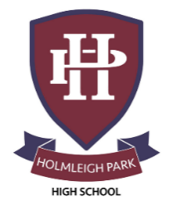
Super Curriculum – Year 12



Subject: English Language & Literature

Reading Task Location to Visit

Research Task Creative Task
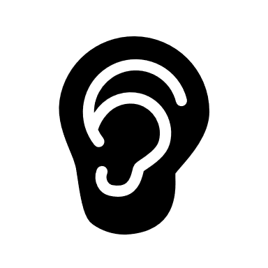
Listening Task Writing Task


Watching Task Independent Project

Submit a blog to the English Language Google classroom regarding your interpretations of the studied texts or others | Visit The British Library - https://www.bl.uk/events | Arrange a visit to a local primary school to research how students learn to read and write
Set up a blog where you write about an issue or subject important to you | Listen to Word of Mouth podcasts on BBC Radio 4 iPlayer | Research how language is used to uphold power – visit the Royal Courts of Justice, download political speeches from the Gov.co.uk, etc.
‘You Say Potato’ or ‘Spell it out’ by David Crystal | Read opinion-based writings such as:  https://www.independent.co.uk/voices | Read opinion-based writings such as:  https://www.theguardian.com/lifeandstyle/series/modern-tribes
Cheltenham Literary Festival. 10th-19th October 2025.  https://www.cheltenhamfestivals.com/literature/ | Listen to BBC Radio 4s Book at Bedtime to help you relax! | Subscribe to the Times Literary Supplement  https://www.the-tls.co.uk/
Listen to podcasts, from Gresham College  https://www.gresham.ac.uk/watch/?subject=art-and-literature | ‘The Wonders of Language: Or: How to Make Noises and Influence People’ by Ian Roberts | ‘The Language Instinct: How the Mind Creates Language’ by Steven Pinker

