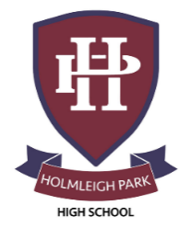
Super Curriculum – Year 12 & 13
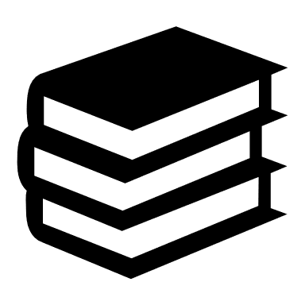
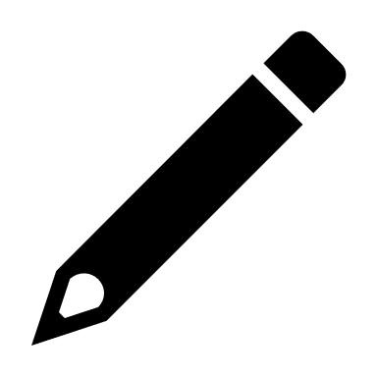

Subject: Chemistry
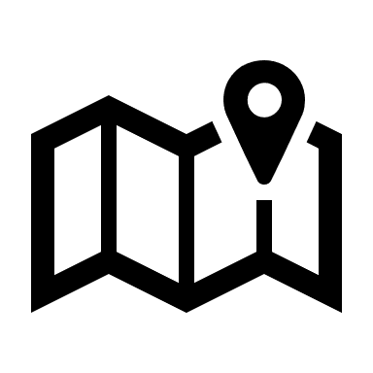
Reading Task Location to Visit

Research Task Creative Task
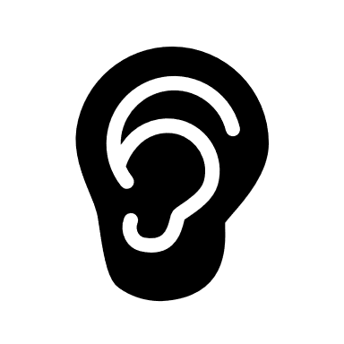
Listening Task Writing Task
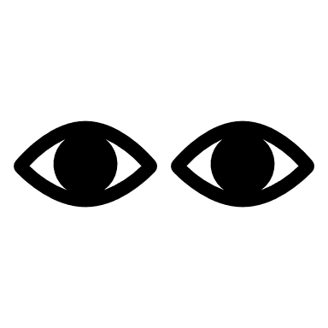
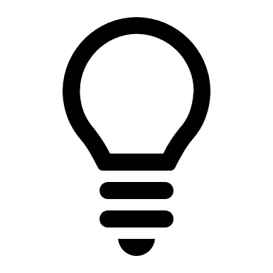
Watching Task Independent Project
Ted Talk on Chemistry of  Smartphones  https://www.ted.com/talks/cathy_mulzer_the_incredible_chemistry_powering_your_smartphone | ‘The Science of Everyday Life: Why Teapots, Dribble, Toast Burns and Light Bulbs Shine’, by Marty Jopson | ‘The Disappearing Spoon...and other true tales from the Periodic Table’, by Sam Kean
Fantastic Four movie and then watch the clip where the science is explained  https://archive.nerdist.com/michio-kaku-explains-the-real-science-behind-fantastic-four/ | 10 weird and wonderful  chemical reactions  https://www.youtube.com/watch?v=0Bt6RPP2ANI | Crash course videos  https://www.youtube.com/playlist?list=PL8dPuuaLjXtPHzzYuWy6fYEaX9mQQ8oGr
Learn to sing the Elements Song by Tom Lehrer. | Create a twitter account,  follow 10 relevant Chemistry  organisations e.g Royal Society  of Chemistry, New scientist, BBC Science news etc | Listen to 5 podcasts of different elements from the periodic table
Read articles from Chemguide to supplement your learning  https://www.chemguide.co.uk/ | Watch science lectures, from the Royal Institution  https://www.youtube.com/c/TheRoyalInstitution/videos | Catalyst Magazine  https://catalyst-magazine.org/
Participate in the Chemistry Olympiad. Run by the Royal Society, and supported by your teachers it enables you to compete with other students. | The Science Museum in London. Tickets are free, but you must pre-book! Everything from Space to Zoology. | The Cheltenham Science Festival. 2-7th June 2026.  https://www.cheltenhamfestivals.org/festivals/science-festival

