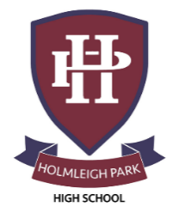
Super Curriculum – Year 12
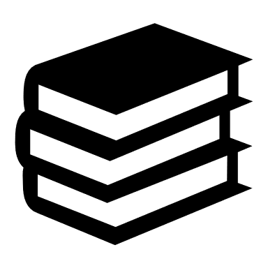


Subject: Biology
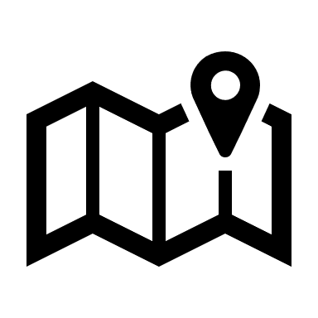
Reading Task Location to Visit

Research Task Creative Task
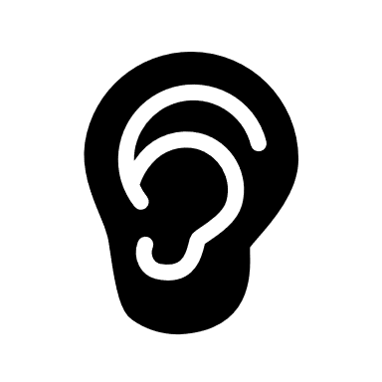
Listening Task Writing Task
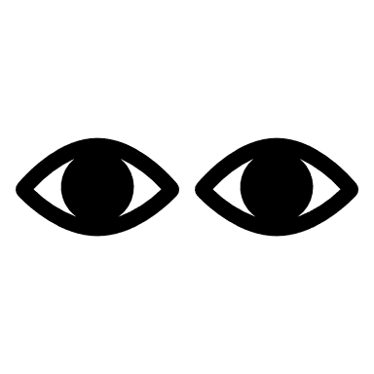
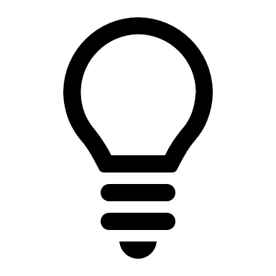
Watching Task Independent Project
‘The immortal life of  Henrietta Lacks’ by Rebecca  Skloot. About HeLa cells and the ethics behind it. | 'The Ancestors Tale' by  Richard Dawkins. Just dip into the chapters that interest you! | ‘The Tale of the Dueling  Neurosurgeons’, by Sam Kean
Secret Universe, The Hidden Life of a Cell  https://www.dailymotion.com/video/x4fjy56 | Cambridge Science Festival – happening online this year!  https://www.festival.cam.ac.uk/ | ‘Silent Spring’ – Rachel  Carson
Create a twitter account,  follow 10 relevant Biology  organisiations e.g. Royal Society of Biology, New Scientist, Nature, BBC Science News ect. | Use New Scientist or  Biological Science Review to  research an area of Biology not  covered by the specification. | Download and listen to  podcast ‘The Infinite Monkey  Cage’
Watch science lectures, from the Royal Institution  https://www.youtube.com/c/TheRoyalInstitution/videos | ‘The Blind Watchmaker’, by Richard Dawkins | ‘Seven Daughters of Eve’, by Brian Sykes
Read the New Scientist. The science department has an open subscription giving you access to the back-catalogue. | The Science Museum in London. Tickets are free, but you must pre-book! Everything from Space to Zoology. | The Cheltenham Science Festival. 2-7th June 2026.  https://www.cheltenhamfestivals.org/festivals/science-festival

