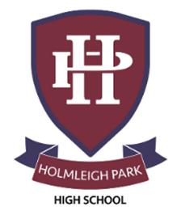
Super Curriculum – Year 12 & 13



Subject: Business Studies

Reading Task Location to Visit

Research Task Creative Task

Listening Task Writing Task


Watching Task Independent Project
Read articles from a publication such as the Economist https://www.economist.com/topics/business | See what is going on around the world in Business  https://www.reuters.com/business/ | Visit Cadbury World, Birmingham and explore the history of chocolate
Explore TED talks on Business  https://www.ted.com/talks?sort=newest&topics%5B0%5D=Business | Watch Business Nightmares  https://www.youtube.com/playlist?list=PLD710B037D5584417 | Watch online lectures from Gresham College  https://www.gresham.ac.uk/watch-now/browse-all?type=525
Research the role of the IMF, and how it’s decisions shape the world  https://www.imf.org/en/home | ‘What you see is what you get’ by Alan Sugar | “Changing World of Work – Gig Economies”  https://www.jbs.cam.ac.uk/2020/the-gig-economy/
The Big Short  (on Disneyplus) | ‘How to win friends and influence people, by Dale Carnegie | Saïd Business School oxford podcasts  https://www.sbs.ox.ac.uk/oxford-answers
The Apprentice, BBC | ‘Adapt, by Tim Hartford | Freakonomics Radio- economics podcast  https://freakonomics.com/

