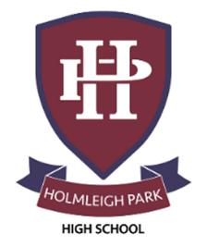
Super Curriculum – Year 12 & 13



Subject: Art and Photography

Reading Task Location to Visit

Research Task Creative Task

Listening Task Writing Task


Watching Task Independent Project
Proactively research artists who inspire you | Make a scrapbook, made from recycled materials | Make an effort to visit local galleries, or venture further afield such as to London.
Look for a range of source material:  Landscapes, gardens, nature, city streets, summer skies | Discover artists stories through the Tate Gallery https://www.tate.org.uk/art/stories | Find new and interesting artists, by interacting regularly with artwork of the day  https://artsandculture.google.com/
Use online scrapbooks such as Pinterest in order to collect ideas and inspiration  https://www.pinterest.co.uk/ | ‘100 Ideas that Changed Photography’, by Mary Warner Marien | Visit Cheltenham, and look at the range of street art/graffiti, from the Paint Festival  https://www.cheltenhampaintfestival.co.uk/
Britain in Focus: A Photographic History  https://www.youtube.com/watch?v=glPF66xes_A | ‘The Power of Art’, by Simon Schama | Listen to the Grayson Perry Reith Lectures  https://www.bbc.co.uk/programmes/b03969vt
Visit the Google Cultural Institute Art Project website. This is an ongoing project  https://artsandculture.google.com/partner/uffizi-gallery?hl=en | Buy a concertina sketchbook and make a continuous drawing that evolves and continues across many pages. | Pick a theme and try to take a series of connected photos. Consider: landscape, interiors, still life, portraits, figures.

