Javelin House Bio
Javelin House is named after the mighty Javelin aircraft; a twin-engine T tailed, delta wing subsonic night and all-weather aircraft, built by the Gloster Aircraft Company in response to the threat of jet powered strategic bombers with atomic weaponry after the Second World War. The Javelin was the first aircraft to be capable of all-weather fighting and boasted a special ‘delta wing’ design that allowed unprecedented manoeuvrability.

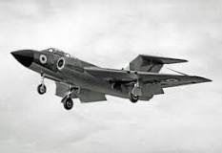The Javelin aircraft

In 1947 Gloster Aircraft responded to the call from the Air Ministry with its Javelin designs and prototypes. The craft fulfilled a specification for ‘a two seater, high performance night fighter capable of intercepting enemy aircraft at heights of 40,00 ft.’ The Javelin would also be capable of performing rapid ascents, attaining an altitude of 45,000 ft within 10 minutes of ignition, a minimum flight endurance of two hours and a take off distance of 1,500 yards.

The Javelin entered service with the RAF in 1956 and quickly superseded the Venom. It was succeeded in the interceptor role by the English Electric Lighting, a supersonic aircraft that was capable of more than double the Javelin’s top speed and served for much of its life alongside this craft. The Javelin was withdrawn from service in 1968 as modifications in design brought about more capable versions of the Lightning.
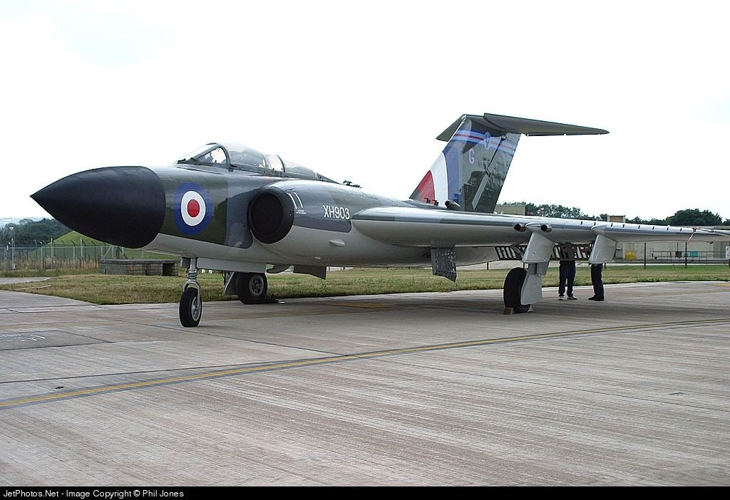
The restored Javelin Aircraft that is currently at the Jet Age Museum.
The Javelin is a very important craft in the history of aviation due to its design. Powered by two turbojets it delivered twice the power of a Meteor and three times that of a Venom. The delta wings allowed for levels of control and manoeuvrability previously unattainable. Pilots were unanimous of their praise for the handling qualities of the Javelin, stating that the Javelin “ is a beautiful aircraft to fly …indeed, flying a Javelin after the Venom is like driving a Bentley after an MG.”

I encourage students in Javelin House to adopt the jets characteristics by developing their skills and resilience so that they can learn ‘in all weathers’. They are encouraged to be fearless in their exploration of knowledge and approach life with a pioneering spirit.

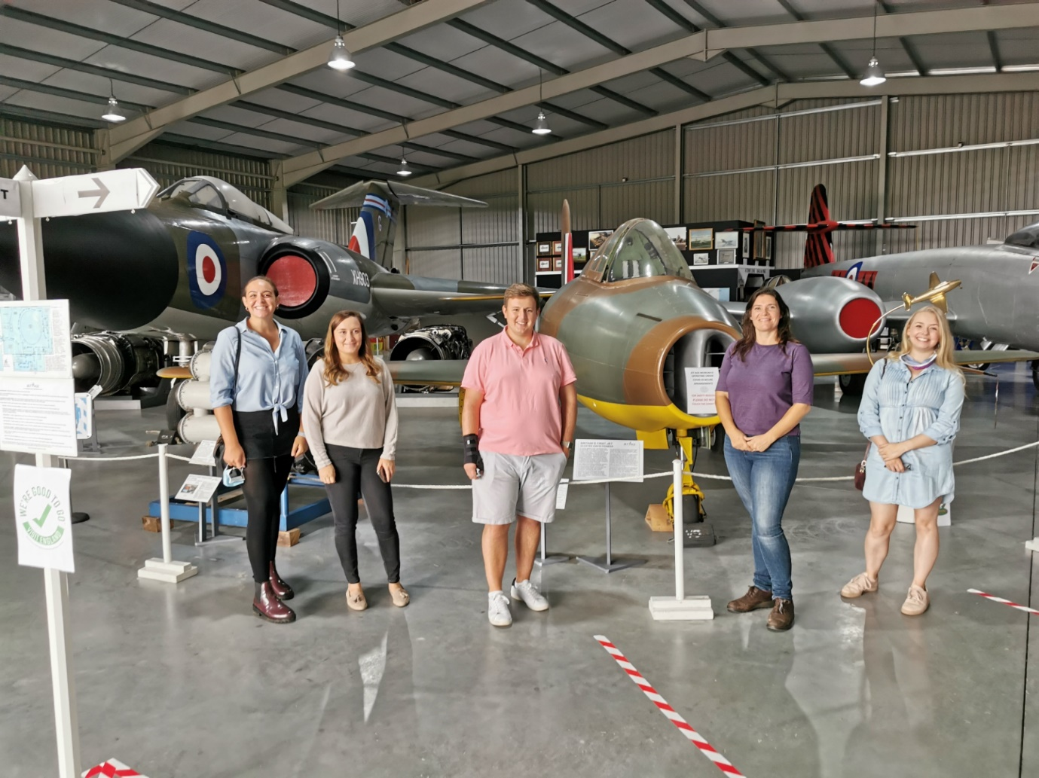
We visited the Jet Age Museum in July 2020 to visit and find out about our House Emblems. It was a really interesting day, the team at the museum were welcoming and highly knowledgeable. I would highly recommend a visit when you are able.

Mrs Kingston, Head of Javelin House.

